**How does learning happen?**

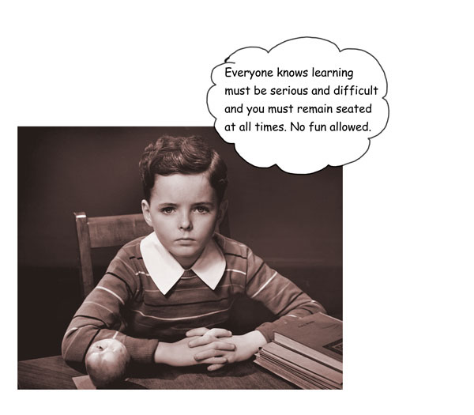

Simply put, learning can be described in the following way (you’ll learn more about the details when we study the brain):

1. The Central Nervous System (brain and spinal cord) are made of cells called neurons.
2. Neurons have many fibres extending from them. These fibres are the key to learning because they can make connections between cells.

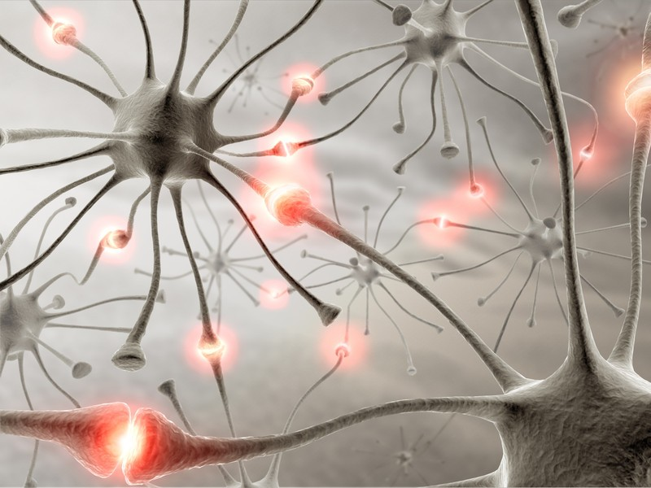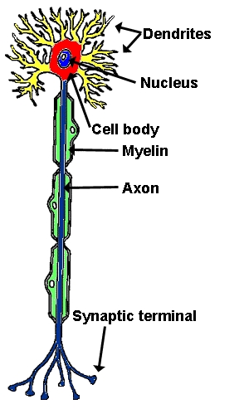

1. When cells are connected to each other, they form neural pathways. These connections and pathways ‘store’ knowledge that has been learned.
2. When one cell in the pathway is activated, a signal is sent to all of the cells in the pathway in a chain reaction.
3. The more times a neural pathway is activated the connections between cells become stronger and more plentiful. The more connections, the faster the information can be sent and the faster the chain reaction.

* Think of singing the song ‘Twinkle Twinkle Little Star”. The very first time you sing the song, you don’t know the words because no neural pathways exist. The next time you wing it, it is easier to remember the words because you have started to create a neural pathway. Eventually, all you need to hear is “Twinkle Twinkle…” and the rest just comes into your brain. This happens because you have forged a strong neural pathway with many connections through the repetition of singing the song.

1. **Repetition is therefore the KEY to learning!**
2. Without repetition, what the brain is able to recall after initially learning something diminishes with time. The recall graph shows the percentage of recall over time, and more importantly, the percentage of information forgotten.

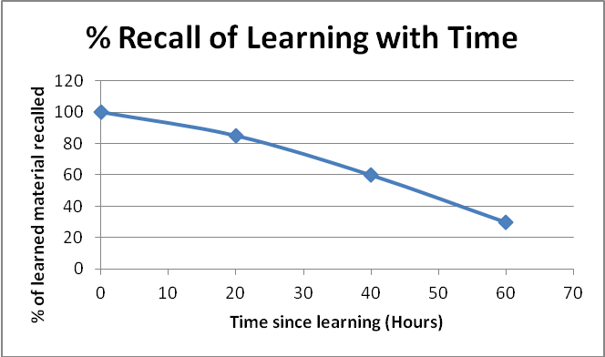

1. So, if you have a quiz on material learned the day before, without review, you could expect to score 80%. Without review, the further out the test is from learning the material, the lower you can expect to score!
2. To be efficient as a learner, you need to expose the brain to the information you with to learn and remember at key times. These are: 24 hours, 48 hours, one week and once per month (at least) for as long as you wish to remember the details. Through repetition, knowledge can be kept at an optimal level.
3. So what can YOU do to maximize repetition and the formation of neural pathways and connections?

* Read the textbook prior to class. Pull out key words and concepts and list them on a blank sheet that you should bring to class. This will help you make connections between what you read and what we discuss in class.
* Take notes during lecture. Be an active note taker – using the maximum number of senses. Don’t just copy words but actually think about what you are writing. Ask questions.
* Within 24 hours of class, review your notes for key terms and concepts. Highlight those key terms and concepts in your notes.
* Two days after learning the material, review again. To properly review, you will need to put all of your notes away and then write out what you remember about the topic. Once you have written what you know, use your notes and textbook to correct and add to your descriptions. Use a different colour pen for the additions/corrections.
* Weekly and monthly after learning the material, review your notes, focusing on the highlighted key words and concepts. Then, test yourself again by writing out what you remember. You should see that the number of corrections you need to make diminishes with time.